Hi All,

Please find the 3rd question for the assignment -4 below:

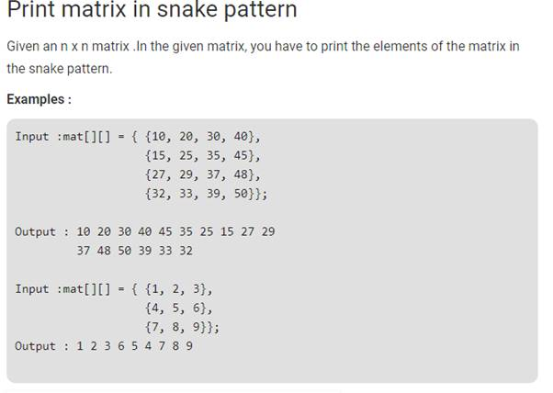

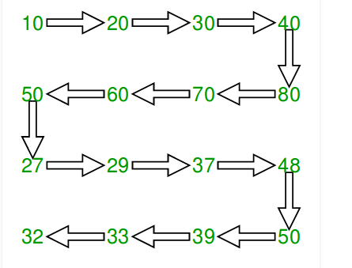

As discussed during the session, send your assignments latest by Wednesday, 7th August 2019.

With Regards,

Aishwarya.K

Hi All,

Please find the questions for the Assignment No: 4 below:

Q1.Check if the frequency of all the digits in a number is same

**Input:** N = 1234567890

**Output:** YES

The frequencies of all the digits are same.

i.e. every digit appears same number of times.

**Input:** N = 1337

**Output:** NO

Q2.Program to check if a given array is Lucky (all elements are different)

An array is lucky if all digits of the number are different.

Please send your assignments latest by Monday, 5th August 2019.

Make sure all of you get the GitHub account and upload the assignments. Share the assignment GitHub link to your respective evaluators and copy Aishwarya Kothandapani  ([KAISHWA1@ford.com](mailto:KAISHWA1@ford.com)) and Shakil ([dshakil@ford.com](mailto:dshakil@ford.com)).

With Regards,

Aishwarya.K